Protein World

Done by

BALAJI.R

ABSTRACTION:

Protein is one of the most popular dietary supplements marketed to athletes. Protein supplements are promoted to increase muscle mass, prevent protein catabolism and enhance glycogen resynthesis. Methodology: The objective of the study was to explore the composition of protein supplements in terms of protein content, source and cost. All the supplement stores in Vadodara were identified and all protein supplements from their websites were listed. The details of these products were collected from official websites of the respective brands. Products that did not provide Nutrition Facts Panel were excluded. Results: In all, 59 products from 15 brands were surveyed which were in the form of powder (83.05%), bar (13.56%) and beverage (3.39%). The serving sizes varied from 24g to 72g for powders which have to be reconstituted into beverage by adding to milk or water. Serving sizes for bars ranged from 50-80g and for beverages from 414-429ml. Protein content per 100g of product was 80-90g in 11.7%, 70-80g in 30% and 60-70g in 25% of the products. The top protein sources were whey protein concentrate (58.33%), whey protein isolate (50%), milk protein concentrate (23.33%), milk protein isolate (21.66%) and micellar casein (20%). The cost per gram of protein ranged from INR 1.71 to 11.78 for powders and INR 4.95-13.9 for bars. Of the total products, 71.67% contained only sugar, 28.3% only sweetener and 61.6% sugar plus sweetener. Directions for use were not indicated on 20% of the products. Conclusion: The most common source of protein was whey protein concentrate and the protein content of majority of the products ranged from 70-80%.

1. LoginPage.jsp

Program:

<%--

Document : Loginpage

Created on : Sep 8, 2021, 1:30:10 PM

Author : sys

--%>

<%@page contentType="text/html" pageEncoding="UTF-8"%>

<!DOCTYPE html>

<html>

<jsp:include page="header.jsp"></jsp:include>

<jsp:include page="Template.jsp"></jsp:include>

<head>

<meta http-equiv="Content-Type" content="text/html; charset=UTF-8">

<title>JSP Page</title>

</head>

<body style="background-image: url('pro/1.jpg'); background-size: 45%">

<center>

<form action="loginDao" method="POST">

<table style="border: solid white; border-spacing: 15px; opacity: 1; background-color: white">

<tr><td>

<h1>Customer Login</h1>

<div align="left">

<input type="text" name="user" value="" autofocus="" required="" placeholder="username"/><br/><br/>

<input type="password" name="pass" value="" required="" placeholder="password"/><br/><br/>

</div>

<input type="submit" value="submit" style="color: white; background-color: black; border-radius: 4px"/>

<br><br><a href="Registration.jsp" style="color: red">create account</a>

</td></tr> </table>

</form>

</center>

</div>

</body>

<br><br><br>

<jsp:include page="footer.jsp"></jsp:include>

</html>

Output:

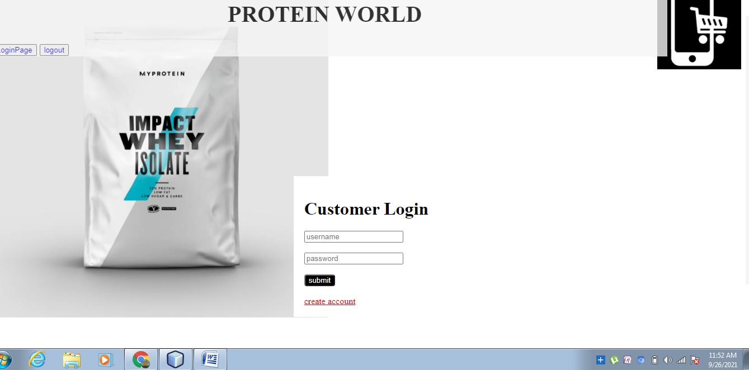

2.Registration.jsp

Program:

<%--

Document : Registration

Created on : Sep 11, 2021, 12:08:39 PM

Author : sys

--%>

<%@page contentType="text/html" pageEncoding="UTF-8"%>

<!DOCTYPE html>

<html>

<jsp:include page="header.jsp"></jsp:include>

<jsp:include page="Template.jsp"></jsp:include>

<head>

<meta http-equiv="Content-Type" content="text/html; charset=UTF-8">

<title>JSP Page</title>

</head>

<body style="background-image:url('pro/powder.jpg'); background-size: 30%">

<div align="center">

<form action="registrationdao" method="post">

<table style="border: solid black; border-spacing: 18px; width: 23%; opacity: 1; background-color: white">

<tr><td>

<h1 style="color: orangered">Registration</h1>

user Name:<br><input type="text" name="username" value="" requrid="" autofocus=""/><br><br/>

E-Mail:<br/><input type="text" name="email" value="" required="" /><br/><br/>

Password:<br><input type="password" name="npass" value=""required=""/><br><br>

Retype Password:<br><input type="password" name="rpass" value="" required=""/><br><br>

Address:<br><textarea name="Address" rows="2" cols="20" required=""></textarea><br><br>

phone:<br><input type="text" name="phone" value=""/><br><br>

<input type="submit" value="submit" />&nbsp;&nbsp;

<input type="reset" value="Reset" /><br><br>

<a href="login.jsp" style="colour: orangered"> Go Back To Login Page</a>

</td></tr>

</table>

</form>

</div>

<jsp:include page="footer.jsp"></jsp:include>

</html>

Output:

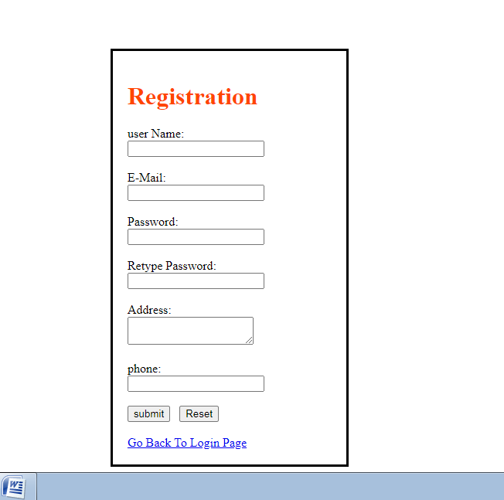

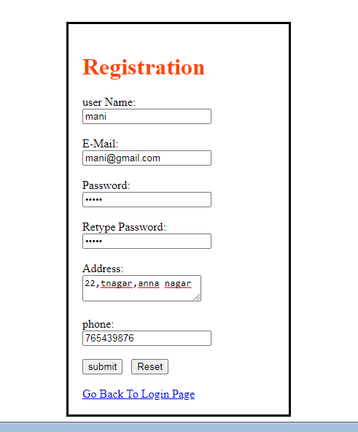

3.Pro.jsp:

Program:

<%@page contentType="text/html" pageEncoding="UTF-8"%>

<%@taglib prefix="c" uri="http://java.sun.com/jsp/jstl/core" %>

<!DOCTYPE html>

<html>

<jsp:include page="header.jsp"></jsp:include>

<jsp:include page="Template.jsp"></jsp:include>

<head>

<meta http-equiv="Content-Type" content="text/html; charset=UTF-8">

<title>B^3 protien's</title>

<style>

.nav{

list-style-type: none;

text-align: left;

margin: 0;

padding: 0;

}

.nav li{

display: inline-block;

padding: 20px;

}

</style>

</head>

<body>

<center>

<h2 style="color: blue">Welcome to B^3 protein</h2>

<table style="border-spacing: 15px; ">

<tr><td><img src="pro/1.jpg" name="product" width="200" height="200" alt="img 1 ">

<details><c:set var="vanilla" value="6600"/>Price : <c:out value="${vanilla}"/><br>

<c:set var="vanilla" value="vanilla"/>Name : <c:out value="${vanilla}"/></details><br/></td>

<td><img src="pro/2.jpg" name="product" width="200" height="200" alt="img 2">

<details><c:set var="choco" value="4800"/>Price : <c:out value="${choco}"/><br>

<c:set var="choco" value="choco"/>Name : <c:out value="${choco}"/></details><br/></td>

<td><img src="pro/3.jpg" name="product" width="200" height="200" alt="img 3">

<details><c:set var="bannana" value="4800"/>Price : <c:out value="${bannana}"/><br>

<c:set var="bannana" value="bannana"/>Name : <c:out value="${bannana}"/></details><br/></td></tr>

<tr><td><img src="pro/4.jpg" name="product" width="200" height="200" alt="img 4">

<details><c:set var="watermelon" value="900"/>Price : <c:out value="${watermelon}"/><br>

<c:set var="watermelon" value="watermelon"/>Name : <c:out value="${watermelon}"/></details><br/></td>

<td><img src="pro/5.jpg" name="product" width="200" height="200" alt="img 5">

<details><c:set var="mixedfruit" value="900"/>Price : <c:out value="${mixedfruit}"/><br>

<c:set var="mixedfruit" value="mixedfruit cre"/>Name : <c:out value="${mixedfruit}"/></details><br/></td>

<td><img src="pro/6.jpg" name="" width="200" height="200" alt="img 6">

<details><c:set var="peach" value="900"/>Price : <c:out value="${peach}"/><br>

<c:set var="peach" value="peach"/>Name : <c:out value="${peach}"/></details><br/></td></tr>

<%-- <tr><td><img src="pro/7.jpg" name="product" width="200" height="200" alt="img 7">

<details><c:set var="mixedfriut" value="1800"/>Price : <c:out value="${mixedfriut}"/><br>

<c:set var="mixedfriut" value="mixedfriut"/>Name : <c:out value="${mixedfriut}"/></details><br/></td>

<td><img src="pro/8.jpg" name="product" width="200" height="200" alt="img 8">

<details><c:set var="watermelon" value="1800"/>Price : <c:out value="${watermelon}"/><br>

<c:set var="watermelon" value="watermelon"/>Name : <c:out value="${watermelon}"/></details><br/></td></tr>

<tr><td><img src="pro/9.jpg" name="product" width="200" height="200" alt="img 9">

<details><c:set var="peach" value="1800"/>Price : <c:out value="${peach}"/><br>

<c:set var="peach" value="peach"/>Name : <c:out value="${peach}"/></details><br/></td> --%>

<td><img src="pro/10.jpg" name="product" width="200" height="200" alt="img 10">

<details><c:set var="raspberry" value="1800"/>Price : <c:out value="${raspberry}"/><br>

<c:set var="raspberry" value="raspberry"/>Name : <c:out value="${raspberry}"/>

<c:set var="raspberry" value=""/>scoop size : </details><br/></td></tr>

<td><img src="pro/11.jpg" name="product" width="200" height="200" alt="img 11">

<details><c:set var="apple" value="1600"/>Price : <c:out value="${apple}"/><br>

<c:set var="apple" value="apple"/>Name : <c:out value="${apple}"/></details><br/></td>

<td><img src="pro/12.jpg" name="product" width="200" height="200" alt="img 12">

<details><c:set var="lemon" value="1600"/>Price : <c:out value="${lemon}"/><br>

<c:set var="lemon" value="lemon"/>Name : <c:out value="${lemon}"/></details><br/></td>

<td><img src="pro/13.jpg" name="product" width="200" height="200" alt="img 13">

<details><c:set var="mojito" value="1600"/>Price : <c:out value="${mojito}"/><br>

<c:set var="mojito" value="mojito"/>Name : <c:out value="${mojito}"/></details><br/></td>

</div> </td><tr> </table>

<form action='<c:url value="/SessionServlet"/>' name='MyForm' method='POST'>

<table style="border: solid red; border-spacing: 15px; opacity: 1; background-color: aliceblue"> <tr>

<td bordercolor='white'><font color='darkorange'> Select Item From Above : </font></td>

<td bordercolor='white'>

<select name='product'>

<option value='vanilla'>vanilla</option>

<option value='choco'>choco</option>

<option value='bannana'>bannana</option>

<option value='mixedfruit'>mixedfruit</option>

<option value='watermelon'>watermelon</option>

<option value='peach'>peach</option>

<option value='raspberry'>raspberry</option>

<option value='apple'>apple</option>

<option value='lemon'>lemon</option>

<option value='mojito'>mojito</option>

</select>

<tr>

<td bordercolor='white'><font color='darkorange'> Number of Product : </font> </td>

<td bordercolor='white'>

<input type= 'text' name='numOfProduct' required="" autofocus=""></td> </tr> <tr><td allign="center">

<font color='darkorange'>Delivery Address : </font><br><textarea name="Delivery Address" rows="3" cols="20" required=""></textarea><br/><br/>

<input type='hidden' value='yproduct' name='PageName'/> </td> </tr> <tr>

<td bordercolor='white'>

<input type='submit' Value='Next'></input></td>

</tr></table></form>

</center>

</body>

<jsp:include page="footer.jsp"></jsp:include>

</html>

Output:

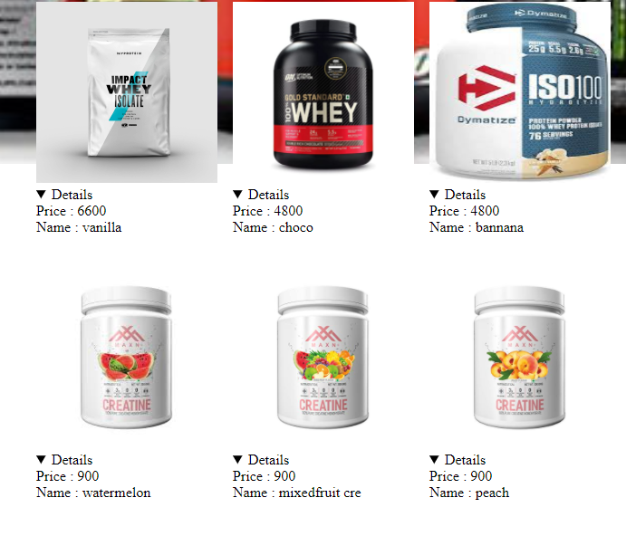

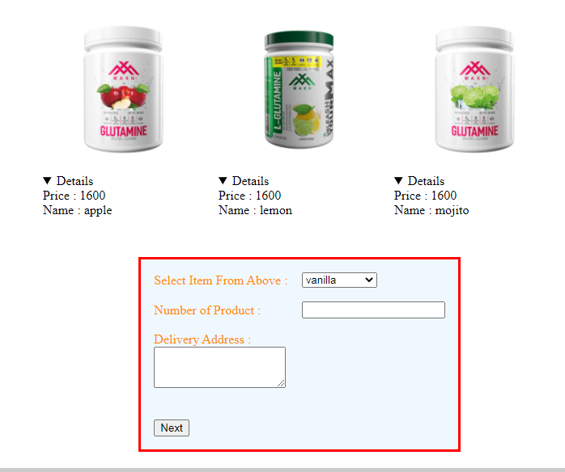

4.Details.jsp

Program:

<%--

Document : details

Created on : Sep 17, 2021, 11:33:37 AM

Author : sys

--%>

<%@ taglib prefix="c" uri="http://java.sun.com/jsp/jstl/core" %>

<%@page contentType="text/html" pageEncoding="UTF-8"%>

<%@taglib prefix="fmt" uri="http://java.sun.com/jsp/jstl/fmt" %>

<!DOCTYPE html>

<html>

<jsp:include page="header.jsp"></jsp:include>

<jsp:include page="Template.jsp"></jsp:include>

<head>

<meta http-equiv="Content-Type" content="text/html; charset=UTF-8">

<title>details</title>

</head>

<body>

<center>

<form action="placeorder.jsp" method="post">

<table style="color: black; border: 3px solid; width: 300px; height: 160px; background-color: seashell" ><tr><td>

<input type="radio" name="bt" value="cash" checked="checked" />Cash On Delivery<br>

<input type="radio" name="bt" value="online" disabled="disabled" /> Online payment<br/><br/>

</td></tr>

<c:set var="product" value="${sessionScope.selproduct}"/>

<c:set var="NumberOfProduct" value="${numproducts}"/>

<c:choose>

<c:when test="${product=='vanilla'}">

<c:set var="amount" value="6600"/>

</c:when>

<c:when test="${product=='choco'}">

<c:set var="amount" value="4500"/>

</c:when>

<c:when test="${product=='bannana'}">

<c:set var="amount" value="4500"/>

</c:when>

<c:when test="${product=='watermelon'}">

<c:set var="amount" value="900"/>

</c:when>

<c:when test="${product=='mixedfruit'}">

<c:set var="amount" value="900"/>

</c:when>

<c:when test="${product=='peach'}">

<c:set var="amount" value="900"/>

</c:when>

<c:when test="${product=='mixedfruit'}">

<c:set var="amount" value="1800"/>

</c:when>

<%-- <c:when test="${product=='watermelon'}">

<c:set var="amount" value="1800"/>

</c:when>

<c:when test="${product=='peach'}">

<c:set var="amount" value="1800"/>

</c:when> --%>

<c:when test="${product=='raspberry'}">

<c:set var="amount" value="1800"/>

</c:when>

<c:when test="${product=='apple'}">

<c:set var="amount" value="1600"/>

</c:when>

<c:when test="${product=='lemon'}">

<c:set var="amount" value="1600"/>

</c:when>

<c:when test="${product=='mojito'}">

<c:set var="amount" value="1600"/>

</c:when>

</c:choose>

<tr><td bordercolor='white'>product : <td colspan="2"><c:out value="${product}"/> </td><br>

<br>

<tr><td bordercolor='white'>Number Of product : <td colspan="2"><c:out value="${NumberOfProduct}"/></td> <br>

<tr><td bordercolor='white'>Total amount: <td colspan="2"><b><fmt:formatNumber pattern="₹##,##,###.##" value="${amount\*NumberOfProduct}"/></b></td><br><br/>

<tr>

<td><input type="submit" value="Submit" /></td></tr>

</table>

</form>

</center>

<h3>Please Read the Terms And Conditions Before Submit</h3>

<a href="Terms.jsp"><h3 style="color: orangered">\*Terms And Conditions</h3></a>

</body>

<jsp:include page="footer.jsp"></jsp:include>

</html>

Output:



5.Details2.jsp

Program:

<%--

Document : details

Created on : Sep 17, 2021, 11:33:37 AM

Author : sys

--%>

<%@ taglib prefix="c" uri="http://java.sun.com/jsp/jstl/core" %>

<%@page contentType="text/html" pageEncoding="UTF-8"%>

<%@taglib prefix="fmt" uri="http://java.sun.com/jsp/jstl/fmt" %>

<!DOCTYPE html>

<html>

<jsp:include page="header.jsp"></jsp:include>

<jsp:include page="Template.jsp"></jsp:include>

<head>

</c:choose>

<tr><td bordercolor='white'>product : <td colspan="2"><c:out value="${product}"/> </td><br>

<br>

<tr><td bordercolor='white'>Number Of product : <td colspan="2"><c:out value="${NumberOfProduct}"/></td> <br>

<tr><td bordercolor='white'>Total amount: <td colspan="2"><b><fmt:formatNumber pattern="₹##,##,###.##" value="${amount\*NumberOfProduct}"/></b></td><br><br/>

<tr>

<td><input type="submit" value="Submit" /></td></tr>

</table>

</form>

</center>

<h3>Please Read the Terms And Conditions Before Submit</h3>

<a href="Terms.jsp"><h3 style="color: orangered">\*Terms And Conditions</h3></a>

</body>

<jsp:include page="footer.jsp"></jsp:include>

</html>

Output:

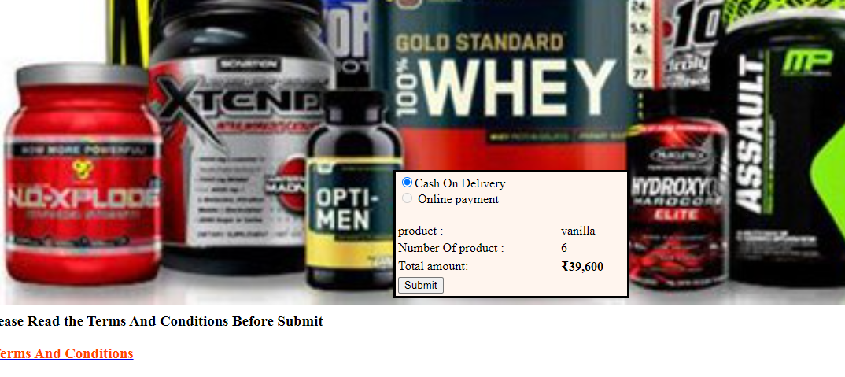

6.Placeorder.jsp

Program:

<%--

Document : placeorder

Created on : Sep 19, 2021, 2:50:14 PM

Author : sys

--%>

<%@page contentType="text/html" pageEncoding="UTF-8"%>

<!DOCTYPE html>

<html>

<jsp:include page="header.jsp"></jsp:include>

<jsp:include page="Template.jsp"></jsp:include>

<head>

<meta http-equiv="Content-Type" content="text/html; charset=UTF-8">

<title>JSP Page</title>

</head>

<body>

<h1>place ORDER!</h1>

</body>

<jsp:include page="footer.jsp"></jsp:include>

</html>

Output:

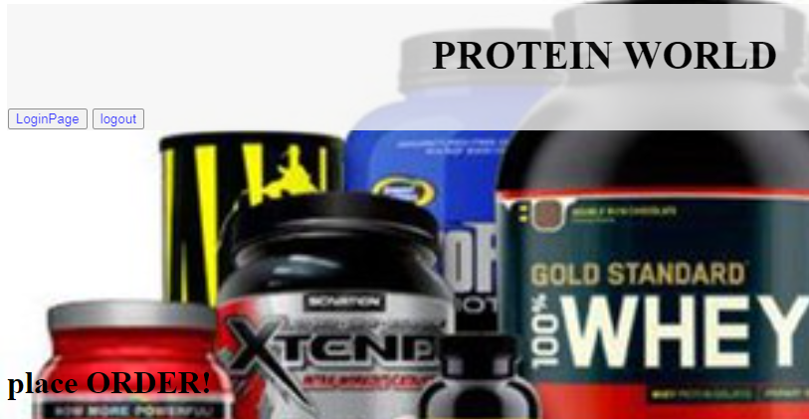

7.Header.jsp

Program:

<%--

Document : header

Created on : Sep 6, 2021, 1:01:08 PM

Author : sys

--%>

<%@page contentType="text/html" pageEncoding="UTF-8"%>

<!DOCTYPE html>

<html>

<head>

<meta http-equiv="Content-Type" content="text/html; charset=UTF-8">

<title>PROTEIN WORLD</title>

<style>

.header{

top: 0;

width: 90%;

text-align: left;

font-size: 20px;

background-color:whitesmoke;

opacity: 0.30;

padding: 1px;

opacity: 0.8;

}

</style>

</head>

<body>

<p>

<img src="pro/Images.jpg" style="float: right; width: 150px; height: 150px;">

<div class="header">

<h1 style="color: black; text-align: center">PROTEIN WORLD</h1>

<a href="LoginPage.jsp"><input type="submit" value="LoginPage" style="color: blue"/></a>

<a href="logout"><input type="submit" value="logout" style="color: blue"/></a>

</div>

</div>

</p>

</body>

<br><br><br><br><br><br>

</html>

8.Header1.jsp:

Program:

<%--

Document : header1

Created on : Sep 6, 2021, 1:20:48 PM

Author : sys

--%>

<%@page contentType="text/html" pageEncoding="UTF-8"%>

<!DOCTYPE html>

<html>

<head>

<meta http-equiv="Content-Type" content="text/html; charset=UTF-8">

<title>PROTEIN WORLD</title>

<style>

.title{

top: 0;

text-align: right;

font-size: 25px;

background-color: aliceblue;

opacity: 0.50;

padding: 1px;

opacity: 0.8;

}

</style>

</head>

<body>

<p>

<div class="title" color='white'>

<h1 style="color: white; text-align: center">PROTEIN WORLD</h1>

<a href="Admin.jsp"><input type="submit" value="Admin" style="color: red;background-color: yellowgreen; border-radius: 4px"/></a>

</div>

</p>

</body>

</html>

Output:



9.Footer.jsp

Program:

<%--

Document : footer

Created on : Sep 4, 2021, 12:53:05 PM

Author : sys

--%>

<%@page contentType="text/html" pageEncoding="UTF-8"%>

<!DOCTYPE html>

<html>

<head>

<meta http-equiv="Content-Type" content="text/html; charset=UTF-8">

<title>PROTEIN WORLD</title>

<style>

.footer{

margin: 0;

bottom: 0;

text-align: left;

font-size: 20px;

background-color: black;

color: white;

opacity: 0.2;

}

</style>

</head>

<body>

<div class="footer">

<p>E-mail :<a href=balajiramesh98@gmail.com" style="color: yellow">balajiramesh98@gmail.com</a></p>

<p>Phone :<a href="tel:044-1234567" style="color: yellow">044-1234567</a></p>

<p>Mobile :<a href="tel:7338967184" style="color: yellow">7338967184</a></p>

</div>

</body>

</html>

Output:

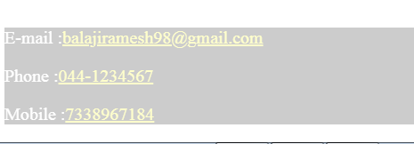

Conclusion:

Protein is one of the most popular dietary supplements marketed to athletes. Protein supplements are promoted to increase muscle mass, prevent protein catabolism and enhance glycogen resynthesis.And this project is small process and you get some conclusion from this project.

APPLICATION USED:

NETBEAN IDE IN 8.2